

**PROJECT REPORT**

**ON**

**FOOD DELIVER SYSTEM**

**BASED ON JAVA**

**For**

**Final Exam**

**Submitted**

**By ACOC**

**Team Name :ACOC**

**Team member :**

**蔡东迪 Drew R8J9400144**

**黄俊辉 Pine R8J9400134**

**颜伟钦 John R8J9400155**

**胡骞 Hale R8J9400132**

**2019.05.06 | 2019.05.16**

**PROJECT INDEX**

**1. Introduction……………………………………………….1**

**1.1 Research Background……………………………..1**

**1.2 Research Skill………………………………………1**

**1.3 Research Purpose…………………………………..1**

**1.4 Main Work of Research……………………………1**

**2. System development platform and application technology**

**2.1 Introduction to Java………………………………..2**

**2.2 Introduction to MySQL…………………………….2**

**2.3 Introduction to NetBeans…………………………..2**

**2.4 Requirements of Development Environment……..2**

**3. System requirements analysis…………………………….3**

**3.1 Feasibility analysis…………………………………..3**

**3.2 Function needs analysis……………………………..3**

**4. System design………………………………………………4**

**4.1 Design of each function module of the System……..4**

**4.2** **Design of Database…………………………………...4**

**5. System Implementation…………………………………….5**

**5.1 Main function module implement……………………5**

**5.1.Restaurant Login………………………………………5**

**5.1.2User Login……………………………………………...5**

**5.2ExtendedFunctionInterface…………………………...5**

**Reference………………………………………………………7**

**Thanks…………………………………………………………8**

**TEAM DESCRIPTION & OVERVIEW**

**About us: ACOC means A CUP OF COFFEE .Because this system is based on JAVA , and the logo of JAVA is a picture of a cup of coffee .Thus ACOC was generated naturally .It is a precious journey for us .We gather together to discuss the design of interfaces and codes in order to make the system look more beautiful and concise .When some problems knock the door ,we surf the internet ,ask for help from teachers to handle them .Although till the deadline ,our project is not completed .But we hold the firm believe that it is a good experience for all of us .**

**CERTIFICATE**

This is to certify that this report ,titled Food deliver system, embodies the original work done by ACOC team in partial fulfilment of their course requirement at NIIT.

coordinator

**ACKNOWLEDGEMENT**

The success and final outcome of this project required a lot of guidance and assistance from many people and I am extremely privileged to have got this all along the completion of my project. All that I have done is only due to such supervision and assistance and I would not forget to thank them.

I respect and thank Mr.Delucia, for providing me Technical support for filechooser and scrollpanel to do the project work and giving us all support and guidance which made me complete the project duly. I am extremely thankful to him for providing such a nice support and guidance, although he had busy schedule managing the corporate affairs.

I owe my deep gratitude to our project guide Mr.Ashok, who took keen interest on our project work and guided us all along, till the completion of our project work by providing all the necessary information for developing a good system.

I am thankful to and fortunate enough to get constant encouragement, support and guidance from all Teaching staffs of Software Engineering Major which helped us in successfully completing our project work.

**Sincerely**

**Team name: ACOC**

**PORJECT REPORT**

**FOOD DELIVER SYSTEM**

**Character 1**

* 1. **Research Background**

**C**ontemporary society ,with the development of science and technology is becoming more and more mature ,in people‘s diet ,it is also accelerated with the pace of The Times .Thus , through the network to achieve the process of food and beverage implementation has been replacing artificial ,it is not only save much time , but also more convenient . Considering that , food deliver system is suitable to this fast-paced society.

* 1. **Research Skill**

1. Surf the Internet or go the library to search the reference and data.
2. Based on what we have learned.
3. Ask for help from teacher Ashok and Dulucia.
   1. **Research Purpose**
4. Proficient in JFrame basic structure ,tags and related attributes.
5. Proficient in MySQL database.
6. Implements user register , login ,order , alter information and so on.
7. Implements restaurant register , login , accept order ,add new food and so on.
8. Analyse the problems that we have met in programming and handle them.
9. Proficient what we have learned such as JAVA ,MySQL by project.
   1. **Main work**
10. Design the interfaces of login ,register ,order ,and so on.
11. Create database like user , restaurant ,food and so on.
12. Implement all of functions.

**Character 2**

**2.1 Introduction to JAVA**

**J**ava isan object-oriented programming language, concise, relatively safe, high – performance . With a comprehensive class library, programmers can easily create system diagrams.

Advantage: 1.Concise

2. High portability.

3.Multithreading capability.

4.Relatively Safe.

5.Platform independence.

[**https://www.java.com/zh_CN/**](https://www.java.com/zh_CN/) **To learn more about JAVA.**

**2.2 Introduction to MySQL**

**MySQL** is a data-development platform which owns these capability : safety ,reliable ,smart ,functional and so on . Data are stored in many tables ,which promote the speed of running meanwhile it becomes very flexible .Besides MySQL cost less ,high running speed ,small footprint and open source .Thus ,MySQL becomes very popular.

<https://www.mysql.com/> **To learn more about MySQL**

**2.3 Introduction to NetBeans**

**N**etbeans is developed by Sun Microsystem . NetBeans is an open source software development integration environment, is an open framework, extensible development platform, can be used for Java, C/C++, PHP and other languages development, itself is a development platform, can be extended by extension plug-ins to extend the function.

**2.4 Requirements of Development Environment**

1. Install JDK1.6.0_03 ,JRE1.6.0_03

2. Install Netbeans IDE 7.1.

3. MySQL Server 5.5

4. MySQL Workbench 6.0 CE

5. Windows System

**Character 3**

* 1. **Feasibility Analysis**

**In the information era, people are more strict with the approaches which are used to gain the information .People hope to use less time to gain more information .**

**So this system is suitable to satisfy people and market needs.**

**In running concept ,this system is a small system ,thus it does not need many resource .Besides ,Java has its own security system .which makes this system be more secure when user or restaurant update their information .**

**To summarize ,it is sensible to develop the system.**

* 1. **Function Needs Analysis**

**User**

A: Register new user.

B: Update Information.

C: User can skim restaurants to order meals

**Restaurant**

A: Register new restaurant.

B: Update Information1.

C: If some dishes are not welcomed to customers ,restaurant can delete them

D: When some new dishes are pushed out ,restaurant can add them to its main interface.

E: Accept order from customers (Automatical).

# Character 4

**4.1 Design of each function module of the system**

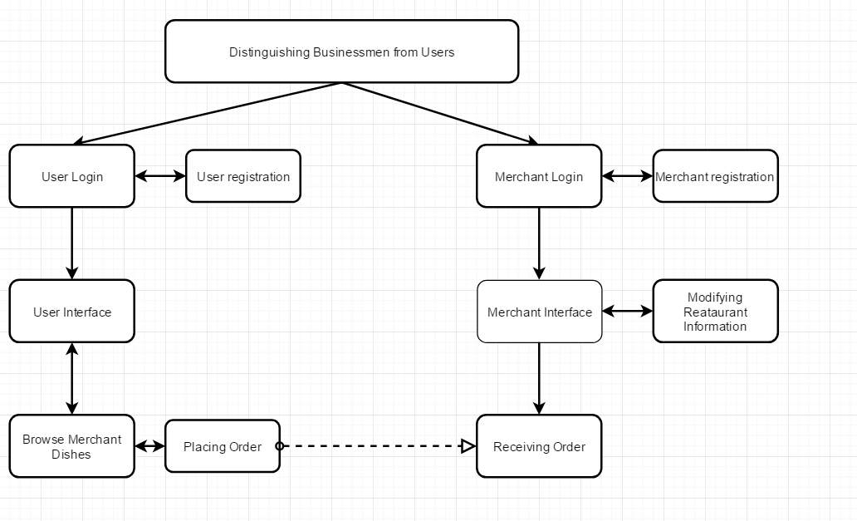

**4.2 Design of Database**

**Table_4.1 Restaurant database table**

|  |  |  |  |  |  |
| --- | --- | --- | --- | --- | --- |
| Serial Number | Column  Name | Type of  Data | Allow to be null | Length | PS |
| **1** | **Incre_ID** | **int** | **no** | **20** | **Primary**  **key** |
| **2** | **Merchant_ID** | **varchar** | **no** | **20** | **Unique key** |
| **3** | **Password** | **varchar** | **no** | **20** |  |
| **4** | **Telephone number** | **Int** | **no** | **11** | **Must be**  **11** |
| **5** | **Address** | **varchar** | **no** | **20** |  |
| **6** | **Name** | **varchar** | **no** | **20** |  |

**Table_4.2 User database table**

|  |  |  |  |  |  |
| --- | --- | --- | --- | --- | --- |
| Serial Number | Column  Name | Type of  Data | Allow to be null | Length | PS |
| **1** | **Incre_ID** | **int** | **no** | **20** | **Primary**  **key** |
| **2** | **User_ID** | **varchar** | **no** | **20** | **Unique key** |
| **3** | **Password** | **varchar** | **no** | **20** |  |
| **4** | **Telephone number** | **Int** | **no** | **11** | **Must be**  **11** |
| **5** | **Address** | **varchar** | **no** | **20** |  |
| **6** | **Name** | **varchar** | **no** | **20** |  |

**Table_4.3 Dish database table**

|  |  |  |  |  |  |
| --- | --- | --- | --- | --- | --- |
| Serial Number | Column  Name | Type of  Data | Allow to be null | Length | PS |
| **1** | **Photo address** | **varchar** | **yes** | **200** |  |
| **2** | **Name** | **varchar** | **no** | **20** |  |
| **3** | **Price** | **double** | **no** | **20** |  |
| **4** | **Description** | **varchar** | **no** | **50** |  |

**Table_4.4 Goods**

|  |  |  |  |  |  |
| --- | --- | --- | --- | --- | --- |
| Serial Number | Column  Name | Type of  Data | Allow to be null | Length | PS |
| **1** | **Incre_ID** | **int** | **no** | **20** | **Primary**  **key** |
| **2** | **Dish1** | **varchar** | **no** | **20** |  |
| **3** | **Num1** | **int** | **no** | **20** |  |
| **4** | **Dish2** | **varchar** | **no** | **20** |  |
| **5** | **Num2** | **int** | **no** | **20** |  |
| **6** | **Dish3** | **varchar** | **no** | **20** |  |
| **7** | **Num3** | **int** | **no** | **20** |  |

**Character 5**

5.1 Main function module implement

5.1.1Restaurant Login module

Enter the login interface ,then choice the restaurant ,then input the id and password to enter to the main interface of your restaurant。

Sample

Choose Restaurant

: 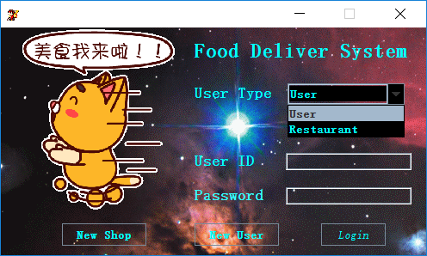

Enter id and password (Example kfc) then enter interface

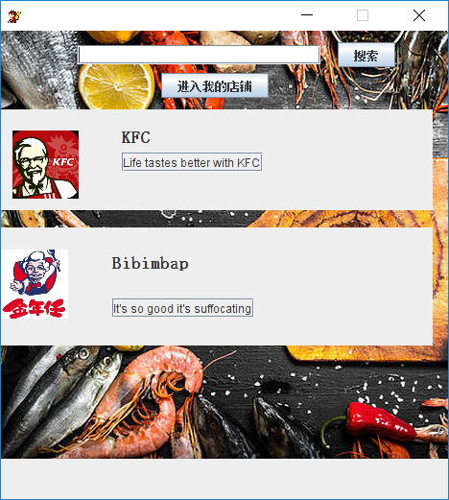

After that click panel can see you menus

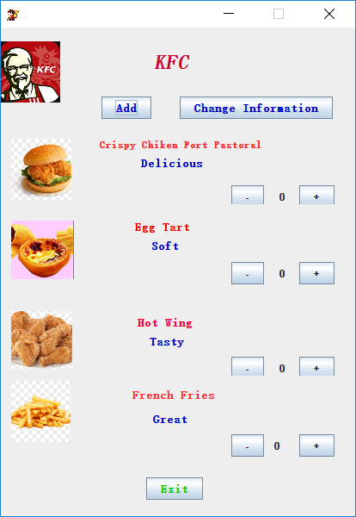

Also you can choose other restaurant to know you competitors.

As follow are key codes for this section

private void jButton1ActionPerformed(java.awt.event.ActionEvent evt) {

try {

Connection con=DBC.getConnection();

PreparedStatement pst;

ResultSet rs;

String infor1="select * from user where UserID=? and UserPassword=?";

String infor2="select * from merchants where MerchantID=? and MerchantPassword=?";

if(Choice.getSelectedItem()=="User"){

pst=con.prepareStatement(infor1);

pst.setString(1,uid.getText());

pst.setString(2,jPasswordField1.getText());

rs=pst.executeQuery();

if(uid.getText().length()==0){

JOptionPane.showMessageDialog(this, "Empty ID","Error",JOptionPane.ERROR_MESSAGE);

}

else if(jPasswordField1.getText().length()==0){

JOptionPane.showMessageDialog(this, "Empty Password","Error",JOptionPane.ERROR_MESSAGE);

}

else if(rs.next()){

UserInterFace obj = new UserInterFace();

obj.show();

dispose();

}

else {

JOptionPane.showMessageDialog(this, "Wrong ID or Password","Error",JOptionPane.ERROR_MESSAGE);

}

}

else{

pst=con.prepareStatement(infor2);

pst.setString(1,uid.getText());

pst.setString(2,jPasswordField1.getText());

rs=pst.executeQuery();

if(uid.getText().length()==0){

JOptionPane.showMessageDialog(this, "Empty ID","Error",JOptionPane.ERROR_MESSAGE);

}

else if(jPasswordField1.getText().length()==0){

JOptionPane.showMessageDialog(this, "Empty Password","Error",JOptionPane.ERROR_MESSAGE);

}

else if(rs.next()){

main a = new main();

a.show();

dispose();

}

else {

JOptionPane.showMessageDialog(this, "Wrong ID or Password","Error",JOptionPane.ERROR_MESSAGE);

}

}

} catch (Exception ex) {

Logger.getLogger(UserLogin.class.getName()).log(Level.SEVERE, null, ex);

}

}

private void jButton2ActionPerformed(java.awt.event.ActionEvent evt) {

UserLogin obj=new UserLogin();

String str=obj.getid();

if(str=="kfc123"){

KFC obj2 = new KFC();

obj2.show();

}

else{

Bibimbap obj2=new Bibimbap();

obj2.show();

}

dispose();

}

private void jButton10MouseClicked(java.awt.event.MouseEvent evt) {

if(Integer.valueOf(num3.getText())==0)

{

JOptionPane.showMessageDialog(rootPane, "the number is 0");

}

else

{

int a=Integer.valueOf(num3.getText())-1;

num3.setText(Integer.toString(a));

}

}

private void jButton11MouseClicked(java.awt.event.MouseEvent evt) {

int a=Integer.valueOf(num3.getText())+1;

num3.setText(Integer.toString(a));

}

private void jButton12MouseClicked(java.awt.event.MouseEvent evt) {

if(Integer.valueOf(num4.getText())==0)

{

JOptionPane.showMessageDialog(rootPane, "the number is 0");

}

else

{

int a=Integer.valueOf(num4.getText())-1;

num4.setText(Integer.toString(a));

}

}

5.1.2 User Login interface module

In the login interface like the restaurant , choose user ,then enter ID and password .When you enter you will see some restaurant click one of them to choose food.

Sample

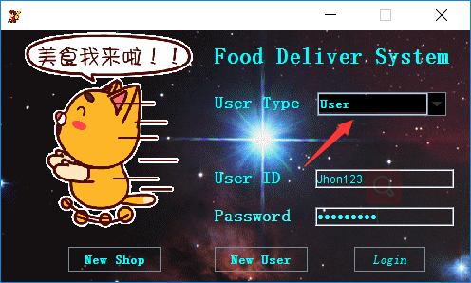

Then(I want to eat Bibimbapuser )

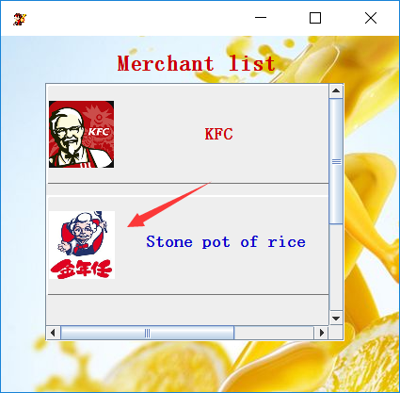

Then choose the delicious food

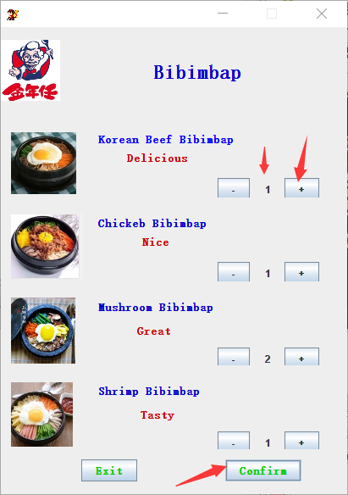

Ps: number can not be less than 0

After click confirm you will see

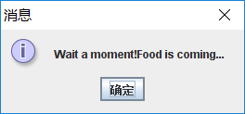

Finally wait and be ready to enjoy food.

Key codes for this section

private void jPanel3MouseClicked(java.awt.event.MouseEvent evt) {

KFCuser obj=new KFCuser();

obj.show();

}

private void jPanel4MouseClicked(java.awt.event.MouseEvent evt) {

Bibimbapuser obj = new Bibimbapuser();

obj.show();

}

public Bibimbapuser() {

ImageIcon imgIcon=new ImageIcon("src/Icon/logo.png");

this.setIconImage(imgIcon.getImage());

initComponents();

setLocationRelativeTo(null);

setResizable(false);

}

private void jButton5MouseClicked(java.awt.event.MouseEvent evt) {

if (Integer.valueOf(num1.getText()) == 0) {

JOptionPane.showMessageDialog(rootPane, "the number is 0");

} else {

int a = Integer.valueOf(num1.getText()) - 1;

num1.setText(Integer.toString(a));

}

}

private void jButton5MouseEntered(java.awt.event.MouseEvent evt) {

// TODO add your handling code here:

}

private void jButton7MouseClicked(java.awt.event.MouseEvent evt) {

int a = Integer.valueOf(num1.getText()) + 1;

num1.setText(Integer.toString(a));

}

private void jButton8MouseClicked(java.awt.event.MouseEvent evt) {

if (Integer.valueOf(num2.getText()) == 0) {

JOptionPane.showMessageDialog(rootPane, "the number is 0");

} else {

int a = Integer.valueOf(num2.getText()) - 1;

num2.setText(Integer.toString(a));

}

}

private void jButton8MouseEntered(java.awt.event.MouseEvent evt) {

// TODO add your handling code here:

}

private void jButton9MouseClicked(java.awt.event.MouseEvent evt) {

int a = Integer.valueOf(num2.getText()) + 1;

num2.setText(Integer.toString(a));

}

5.2 **ExtendedFunctionInterface**

**5.2.1 Register**

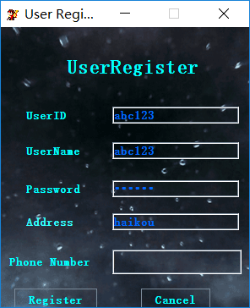 **GIF**

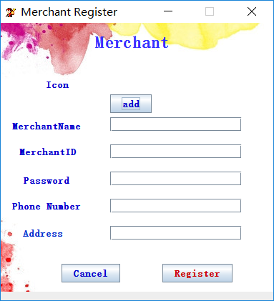

**Key code**

private void insert() {

try {

PreparedStatement pst, pst1;

ResultSet rs;

Connection con = DBC.getConnection();

String sql = "insert into merchants" + " values(default,?,?,?,?,?)";

pst = con.prepareStatement(sql);

pst.setString(1, n1.getText());

pst.setString(2, i1.getText());

pst.setString(3, p1.getText());

pst.setString(4, t1.getText());

pst.setString(5, a1.getText());

int n1 = pst.executeUpdate();

if (n1 > 0) {

JOptionPane.showMessageDialog(this, "Register Successfully");

//NewJFrame n=new NewJFrame();

//n.setVisible(true);

dispose();

}

} catch (Exception e) {

JOptionPane.showMessageDialog(this, e) ;}

private void insert(){

try

{

PreparedStatement pst,pst1;ResultSet rs;

Connection con=DBC.getConnection();

String sql="insert into user"+" values(default,?,?,?,?,?)";

pst=con.prepareStatement(sql);

pst.setString(1,UserID.getText());

pst.setString(2,UserName.getText());

pst.setString(3,UserPassword.getText());

pst.setString(4 ,UserAddress.getText());

pst.setString(5,UserNumber.getText());

int n1=pst.executeUpdate();

if(n1>0){

JOptionPane.showMessageDialog(this,"Register Successfully,Welcome Join");

//NewJFrame n=new NewJFrame();

//n.setVisible(true);

dispose();

}

}

catch(Exception e)

{

JOptionPane.showMessageDialog(this,e);

}

}

**5.2.2 Add new dish for restaurant**

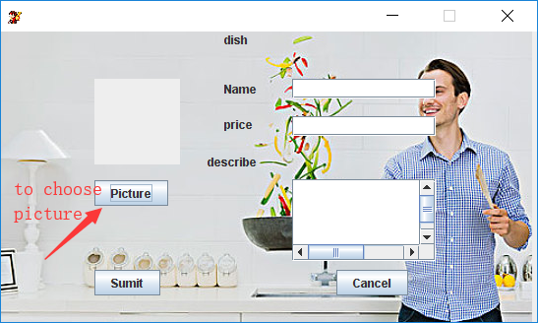

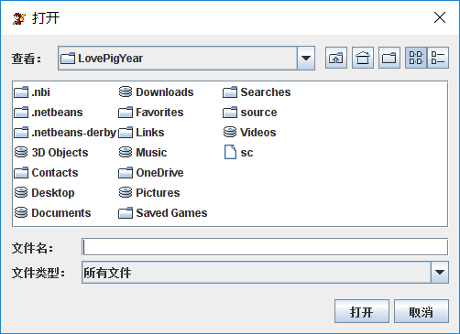

**Key code**

**private void jButton1ActionPerformed(java.awt.event.ActionEvent evt) {**

**try {**

**//check**

**String inputname = n1.getText();**

**Pattern ptname = Pattern.compile("^[a-zA-Z]");**

**Matcher mn1 = ptname.matcher(inputname);**

**String inputprice = pr1.getText();**

**Pattern ptprice = Pattern.compile("^[0-9]+$");**

**Matcher mpr1 = ptprice.matcher(inputprice);**

**if (mn1.find()==false ) {**

**JOptionPane.showMessageDialog(rootPane, "Name should not have illegal character ");**

**}**

**else if (n1.getText().length() < 7) {**

**JOptionPane.showMessageDialog(this, "Name should more than 7");**

**}**

**else if (mpr1.find()==false) {**

**JOptionPane.showMessageDialog(this, "please enter number");**

**} else if (pr1.getText().length()== 0) {**

**JOptionPane.showMessageDialog(this, "please enter price");**

**}**

**else if(Integer.valueOf(pr1.getText())<0)**

**{**

**JOptionPane.showMessageDialog(this, "price should >=0");**

**}**

**else {**

**//databse**

**Connection con = DBC.getConnection();**

**String str = "insert into dish values(default,?,?,?,?)";**

**PreparedStatement pst = con.prepareStatement(str);**

**File file=new File(p1.getIcon().toString());**

**BufferedImage image = ImageIO.read(new File(p1.getIcon().toString()));**

**ImageIO.write(image,"png", new File(System.getProperty("user.dir")+"\\src\\merchant1Icon\\"+file.getName()));**

**File filenew=new File(System.getProperty("user.dir")+"\\src\\merchant1Icon\\"+file.getName());**

**pst.setString(1,filenew.getPath());**

**pst.setString(2, n1.getText());**

**pst.setString(3, pr1.getText());**

**pst.setString(4, d1.getText());**

**int rs=pst.executeUpdate();**

**JOptionPane.showMessageDialog(rootPane, "Enter sucessfully", "Message", WIDTH);**

**//enter again check**

**int choose = JOptionPane.showOptionDialog(rootPane, "Enter again?", "Message", JOptionPane.YES_NO_OPTION, WIDTH, null, null, rootPane);**

**if (choose == 0) {**

**dispose();**

**goodsdetails g = new goodsdetails();**

**g.show();**

**} else {**

**dispose();**

**KFC m=new KFC();**

**m.show();**

**}**

**}**

**} catch (Exception e) {**

**e.printStackTrace();**

**}**

**Reference**

**[1] 《Mysql 技术内幕 InnoDB存储引擎》**

**authority ：姜承尧**

**[2] 《高性能Mysql》**

**[3] 《Java从入门到精通（第三版）》**

**[4] NIIT Textbooks**

**Thanks**

Our team was able to complete this project activity, thanks to our teachers Ashok and Delicia .When we couldn't solve the problems in the project, they gave us help and guidance. The system implementation problem gave us a number of key hints. Let our team members learn a lot of function implementation method, change the thinking.

Thanks sincerely